Hunter, Colin (Drafty)
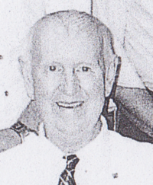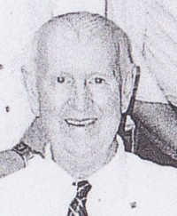
Joined Forests Department c1956, as forest workman in Pemberton district. Retired 2001, after >45 years service. Maintained recreation sites. Worked as a caterer at fires.

